

Test Evidence Dcoument

Oracle Fusion HCM Extracts & Report Version V1



August 18, 2025

yASWANTH KUMAR MUNAGAPATI

**INDEX**

|  |  |  |
| --- | --- | --- |
| S. No | Requirement | Page No |
| 1 | YK_HR_I001_Emp_Details_V1  Assignment ID, BU Name, user Name, Person Number, First Name, Middle Name, Last Name, Manager Name, Employee Status, Last Hire Date, Manager User Name, Collective Agreement Name, Home Phone Number, Home Phone Type, Birth Month, Contact Name, Person Id | 2-5 |
| 2 | YK_EXT_I002_EMP_DETAILS_V1  Institute Id, Hire Date, Person Id, First Name, Middle Name, Last Name, Date of Birth, Gender, Email, Dept Code, Department, Job Code, Job Name, User Name, Assignment Status, FTE, NID, YOE | 6-8 |
| 3 | YK_R001_REPORT_V1 Position Hierarchy Report | 9-10 |

**Requirement 1:** Assignment ID, BU Name, user Name, Person Number, First Name, Middle Name, Last Name, Manager Name, Employee Status, Last Hire Date, Manager User Name, Collective Agreement Name, Home Phone Number, Home Phone Type, Birth Month, Contact Name, Person Id

**Extract Definition**

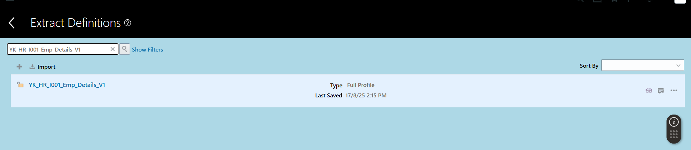

**Extract Run:**  [YK_HR_I001_Emp_Details_081725_V2](https://eiiv-dev2.fa.us6.oraclecloud.com/hcmUI/faces/FuseWelcome?fnd=%3B%3B%3B%3Bfalse%3B256%3B%3B%3B&_afrLoop=40889297149225252&_afrWindowMode=0&_afrWindowId=uliijmnx3&_adf.ctrl-state=3jcu5dwv7_559&_afrFS=16&_afrMT=screen&_afrMFW=1707&_afrMFH=772&_afrMFDW=1536&_afrMFDH=864&_afrMFC=8&_afrMFCI=0&_afrMFM=0&_afrMFR=108&_afrMFG=0&_afrMFS=0&_afrMFO=0)

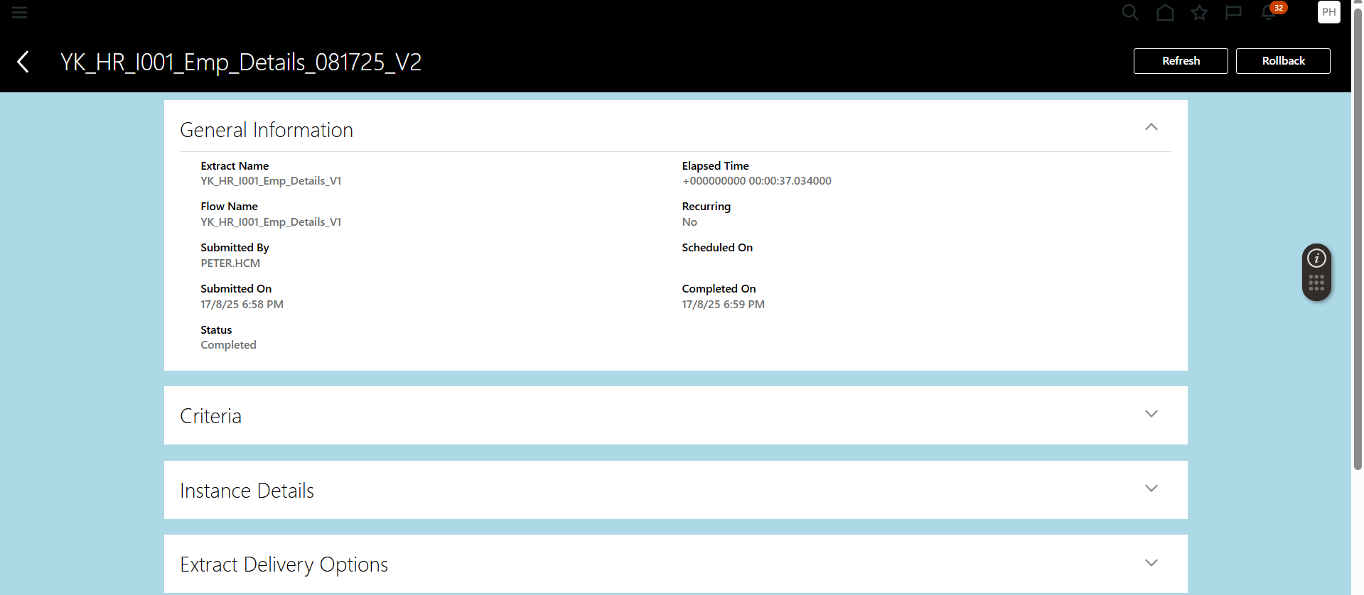

**Extract Delivery Options File**

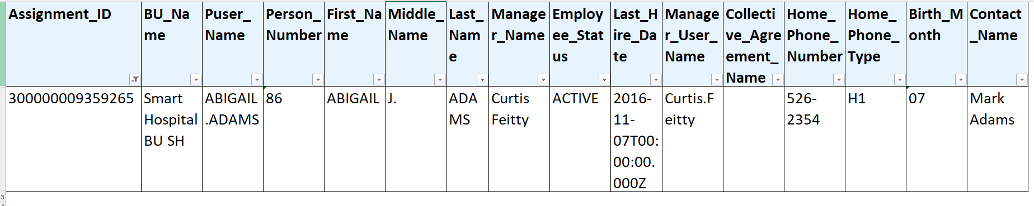

Assignment Id, BU Name, Manager Name, Assignment Status,

,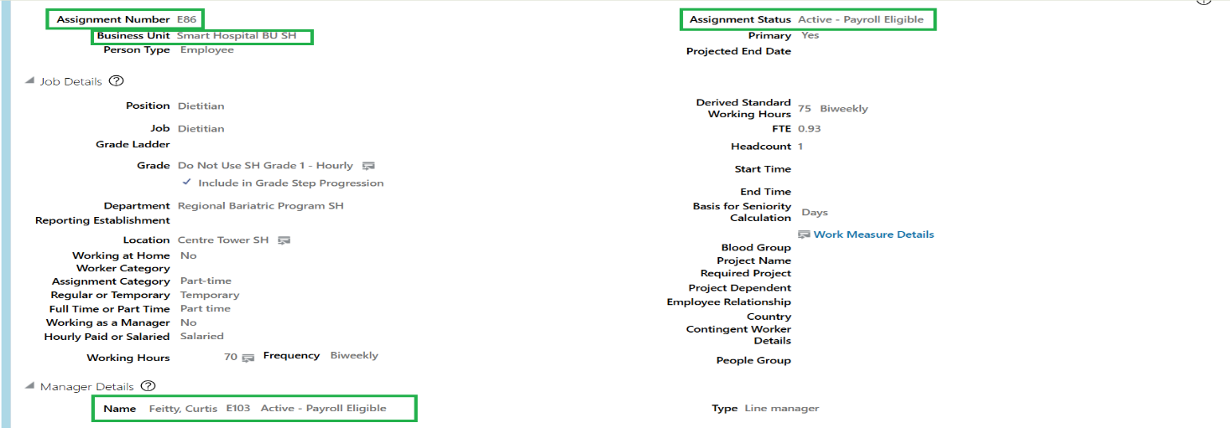

Hire Date

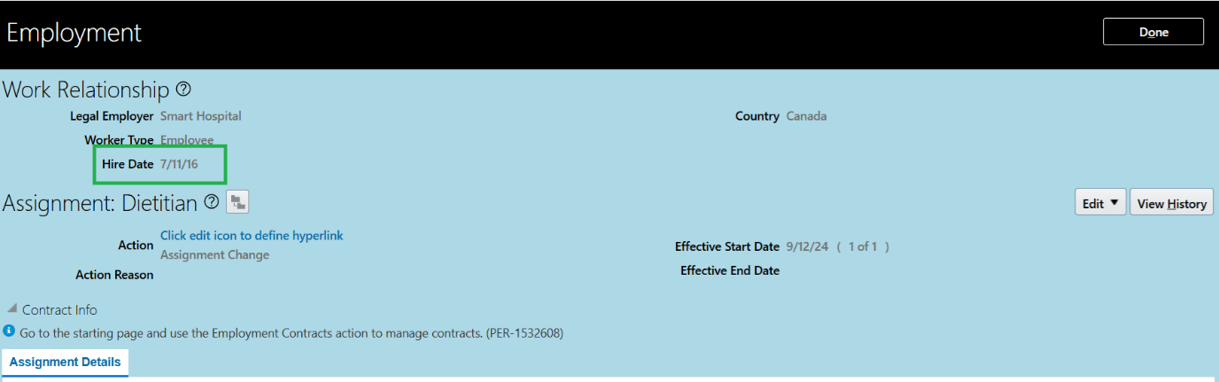

First Name, Last Name, Middle Name, Home Phone Number

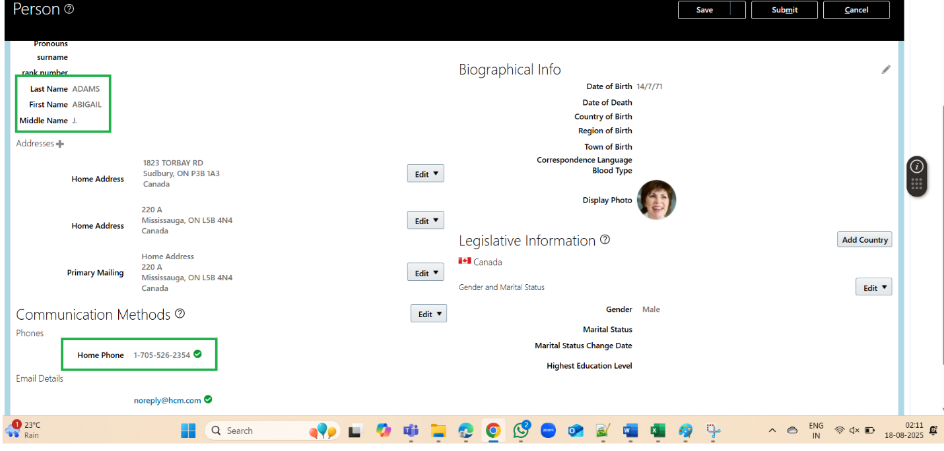

Contact Name

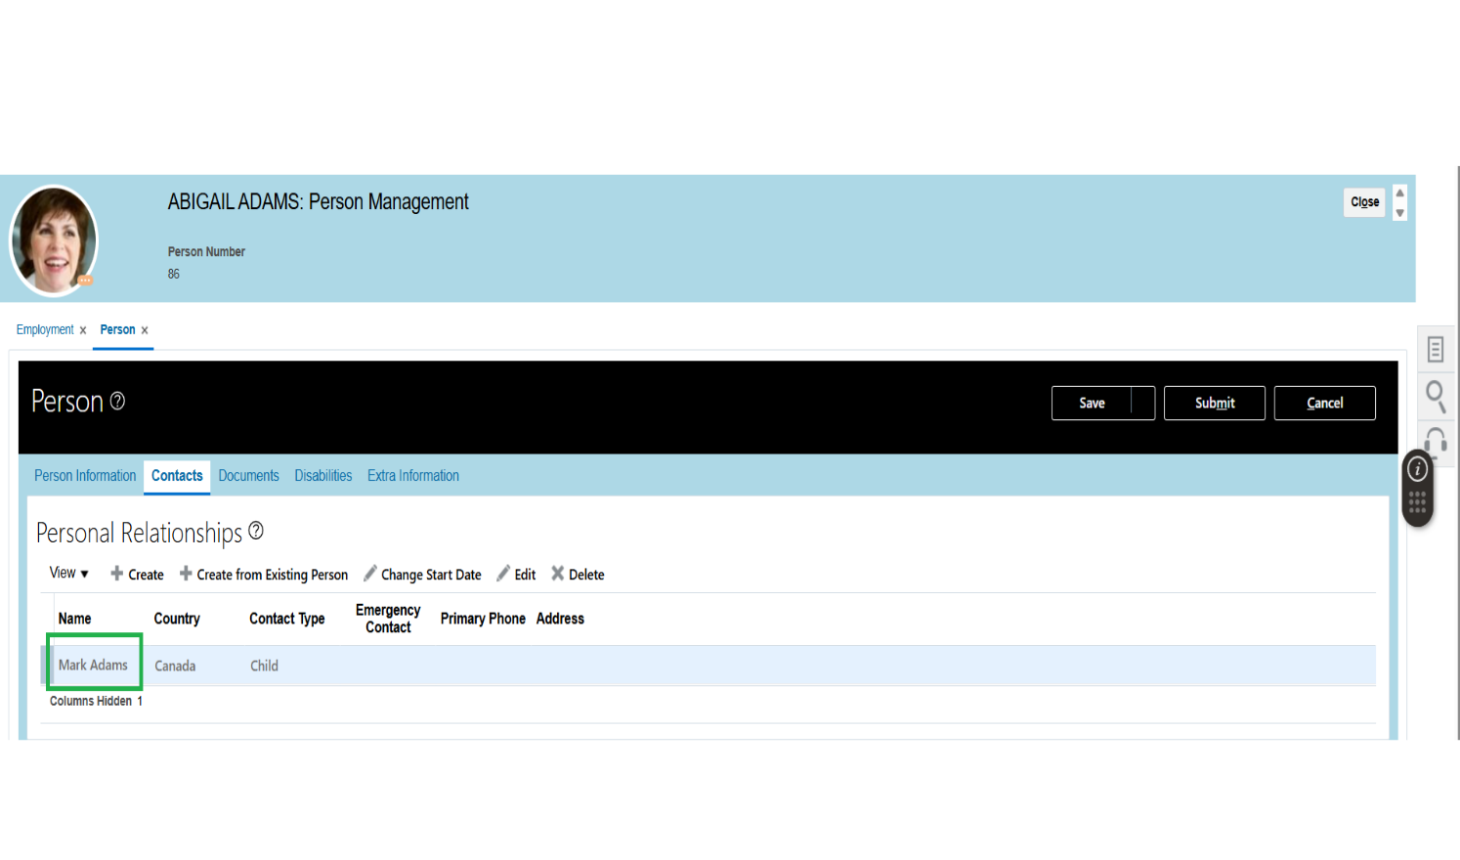

Birth Month

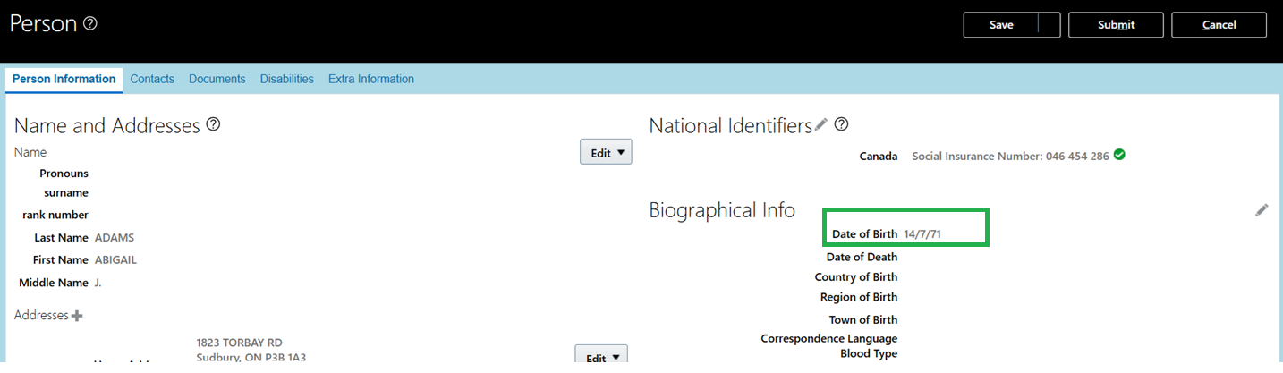

User Name

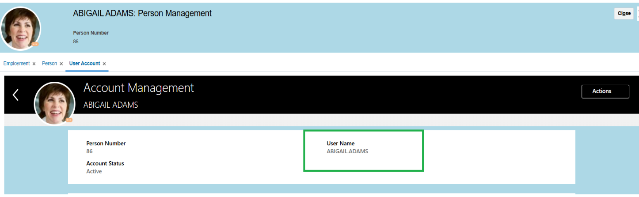

Requirement 2: Institute Id, Hire Date, Person Id, First Name, Middle Name, Last Name, Date of Birth, Gender, Email, Dept Code, Department, Job Code, Job Name, User Name, Assignment Status, FTE, NID, YOE

**Extract Definition**

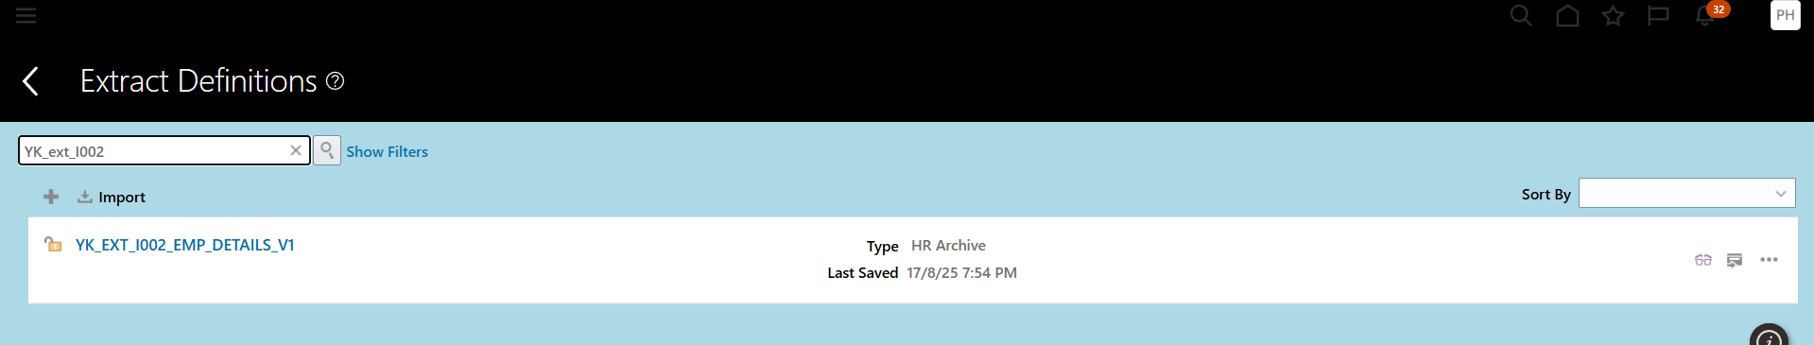

Extract Run**: YK_EXT_I002_EMP_DETAILS_V1_081825_V4**

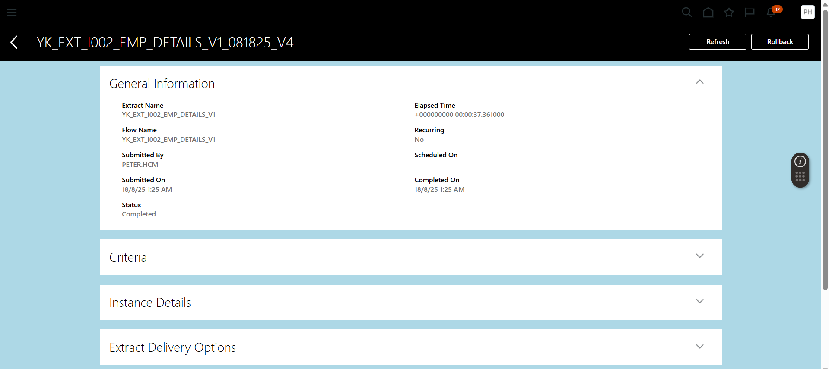

Institute ID: MHS



Hire Date and YOE

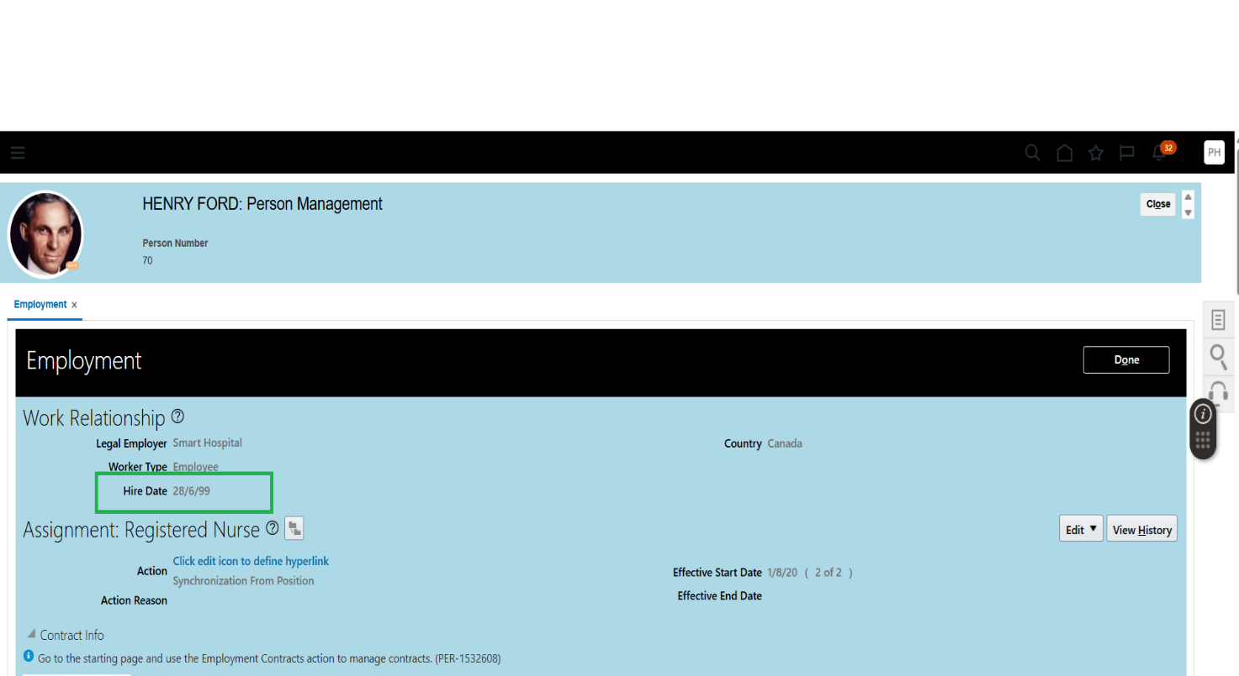

Job, Department Name, Assignment Status

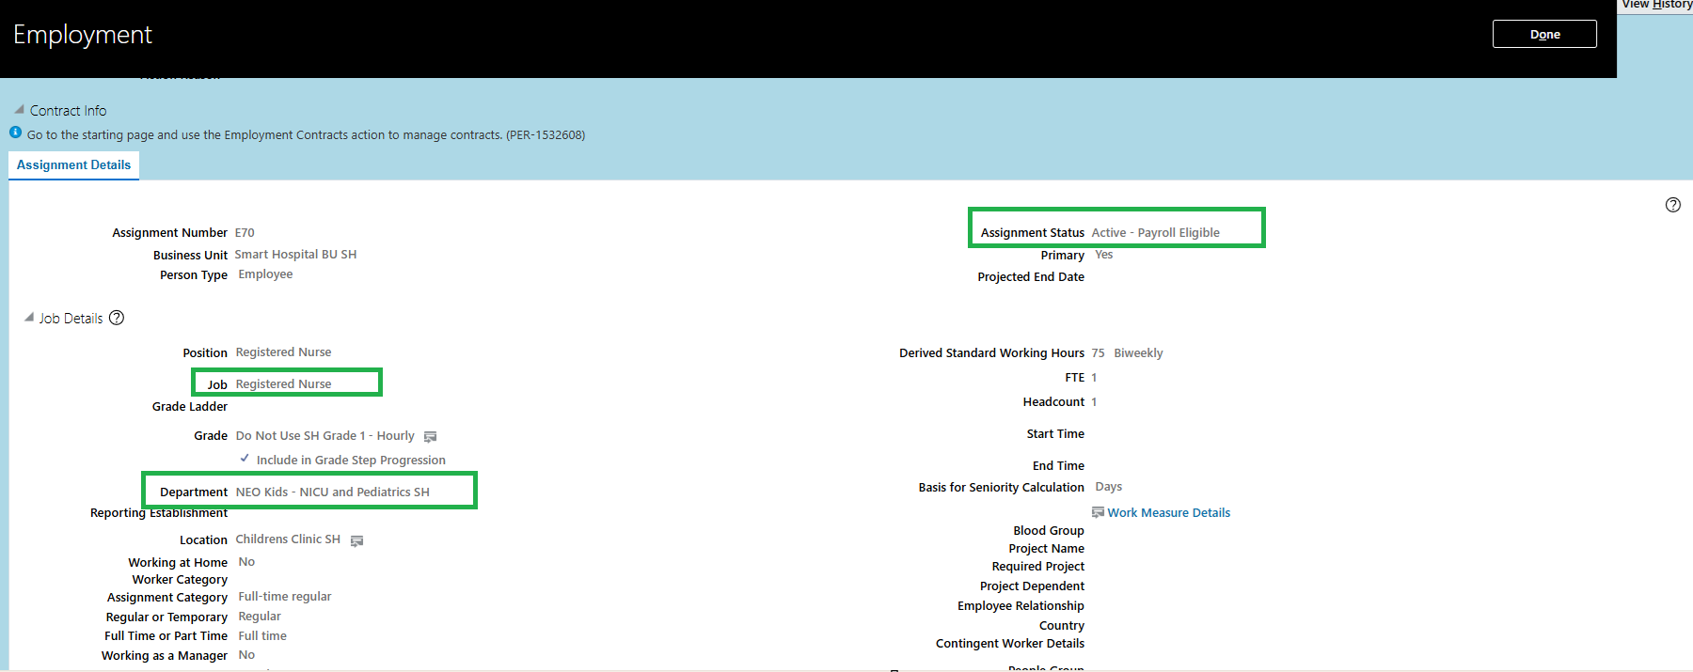

First Name, Last Name, Middle Name, Date of Birth, NID, Email, Gender

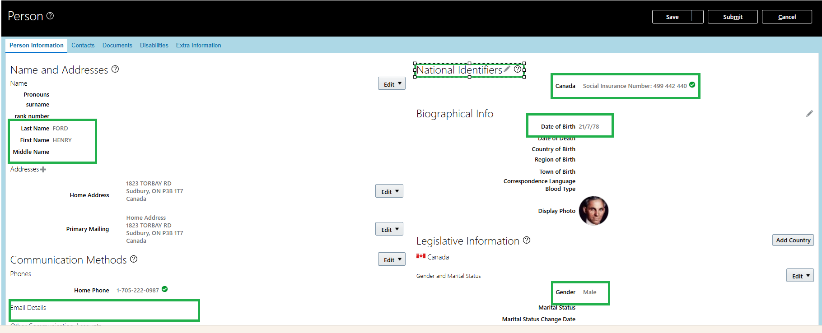

User Name

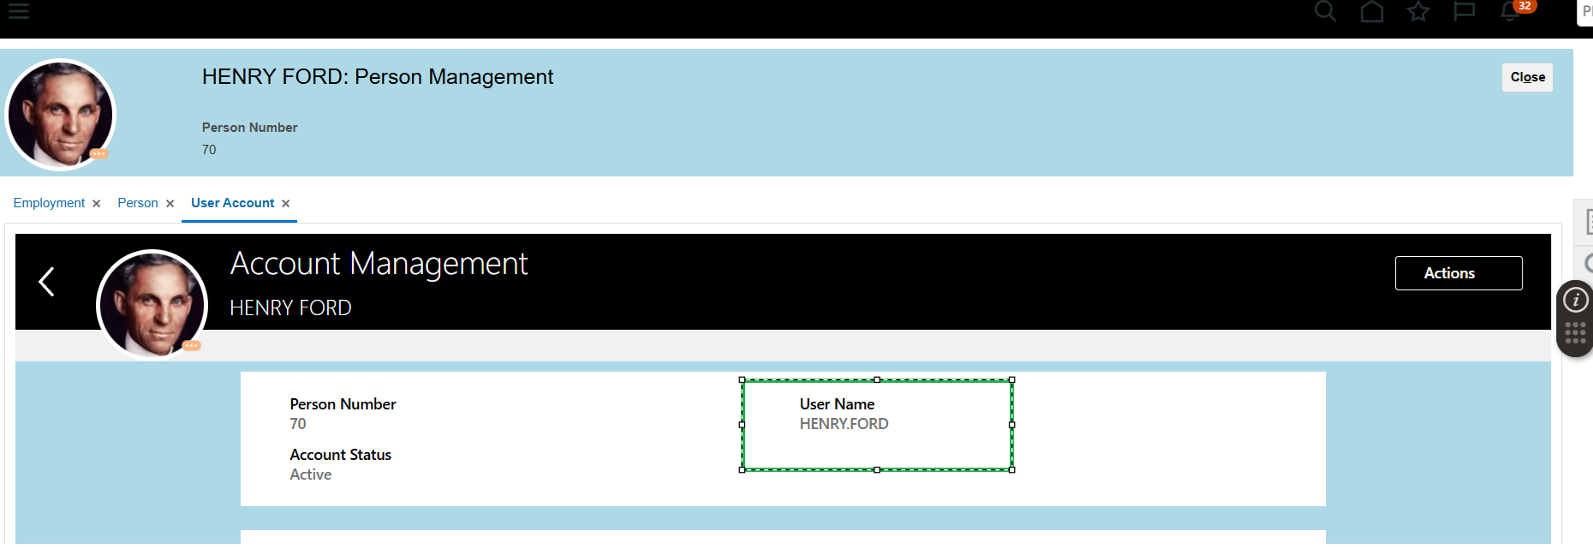

**Requirement 3:** Position Hierarchy Report -

**Data Model: Position_Hier_DM**

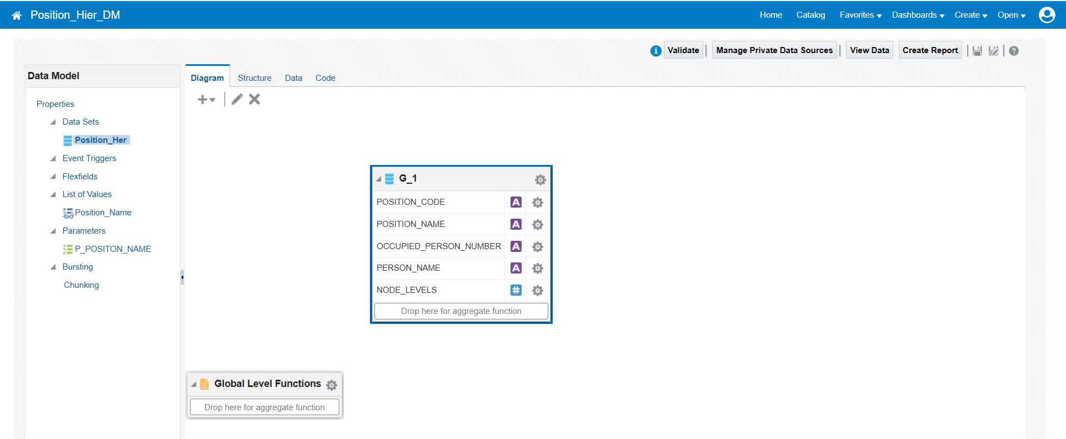

**Data Model Output:**

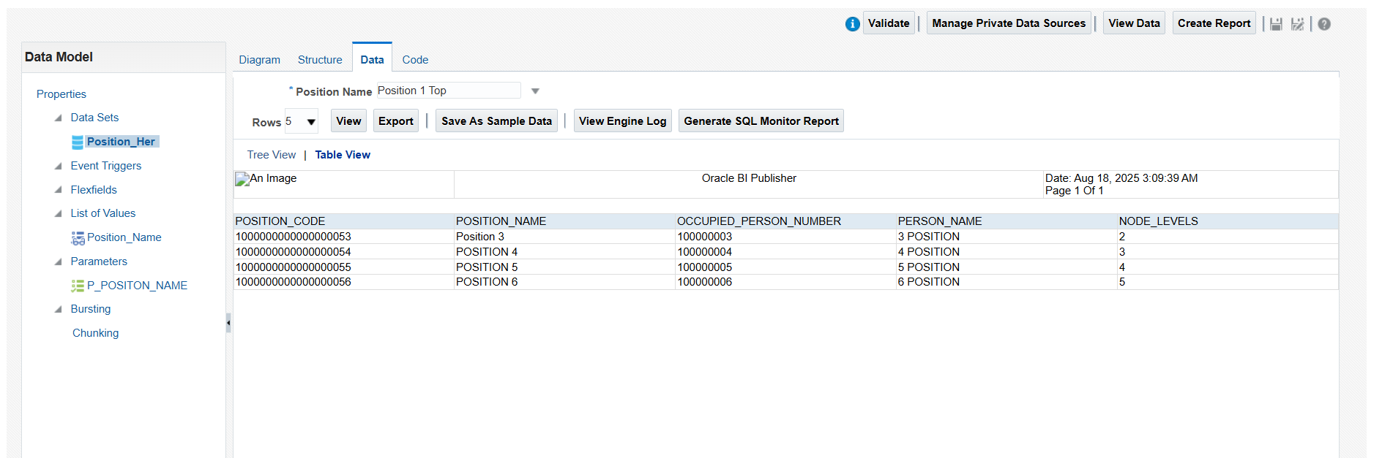

**Report: Position_Hierarchy_Report**

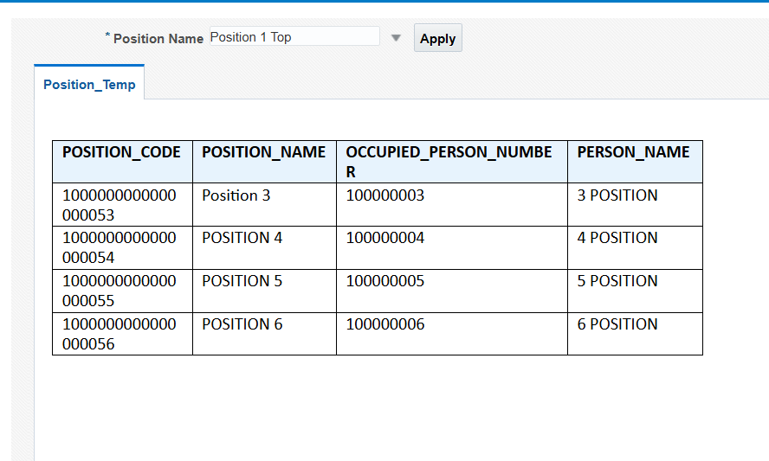

**Thank You**